Study Guide: Finding Ground Distance

- 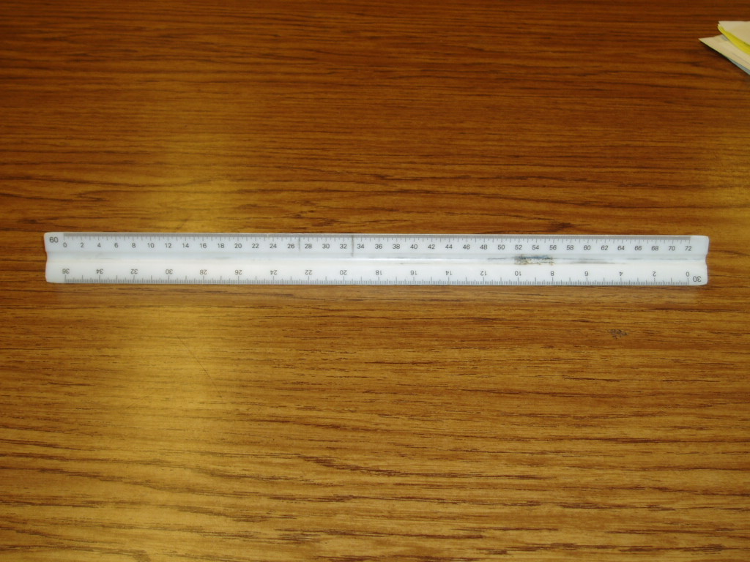Measure the line on the 60-scale side (A to B).
- Take measurement and multiply by 10 to get number of marks.
2 (your measurement) x 10 = 20
- Divide the number of marks by the number of marks in 1 ft to convert into ft. 20 marks/ 720 = .027 ft.

- Multiply marks by the “Map Scale Reciprocal”.
.027 ft x 24,000(map scale reciprocal) = 666ft (ground distance)
- The measurement is now converted from Map Distance-Ground Distance.

Formula: GD= (MSR X MD)/ 720

